What is the Protocol Review and Monitoring Committee (PRMC)?
The role of the Protocol Review and Monitoring Committees is to provide internal oversight of the scientific aspects of all clinical research, including the population sciences, conducted at, and/or coordinated by, the University of Chicago Medicine Comprehensive Cancer Center (UCCCC) and its network sites.

They act as the internal scientific review committee for all cancer-relevant research. Cancer relevant research must be reviewed by the PRMC prior to submission to the Institutional Review Board (IRB).

In addition to initial scientific review and oversight, the PRMC is charged with review of significant amendments to ongoing clinical trials (see below for additional information).

They are also charged with annual accrual monitoring of ongoing clinical trials to ensuring adequate use of cancer center resources and to ensure that our trial portfolio continues to meet the needs of the patients we serve (see below for additional information).

See below to determine if your study require PRMC review or oversight and applicable submission requirements.

Does my study require review by the Cancer Center’s PRMC?

Please refer to Diagram below to determine if your project requires review by the PRMC.

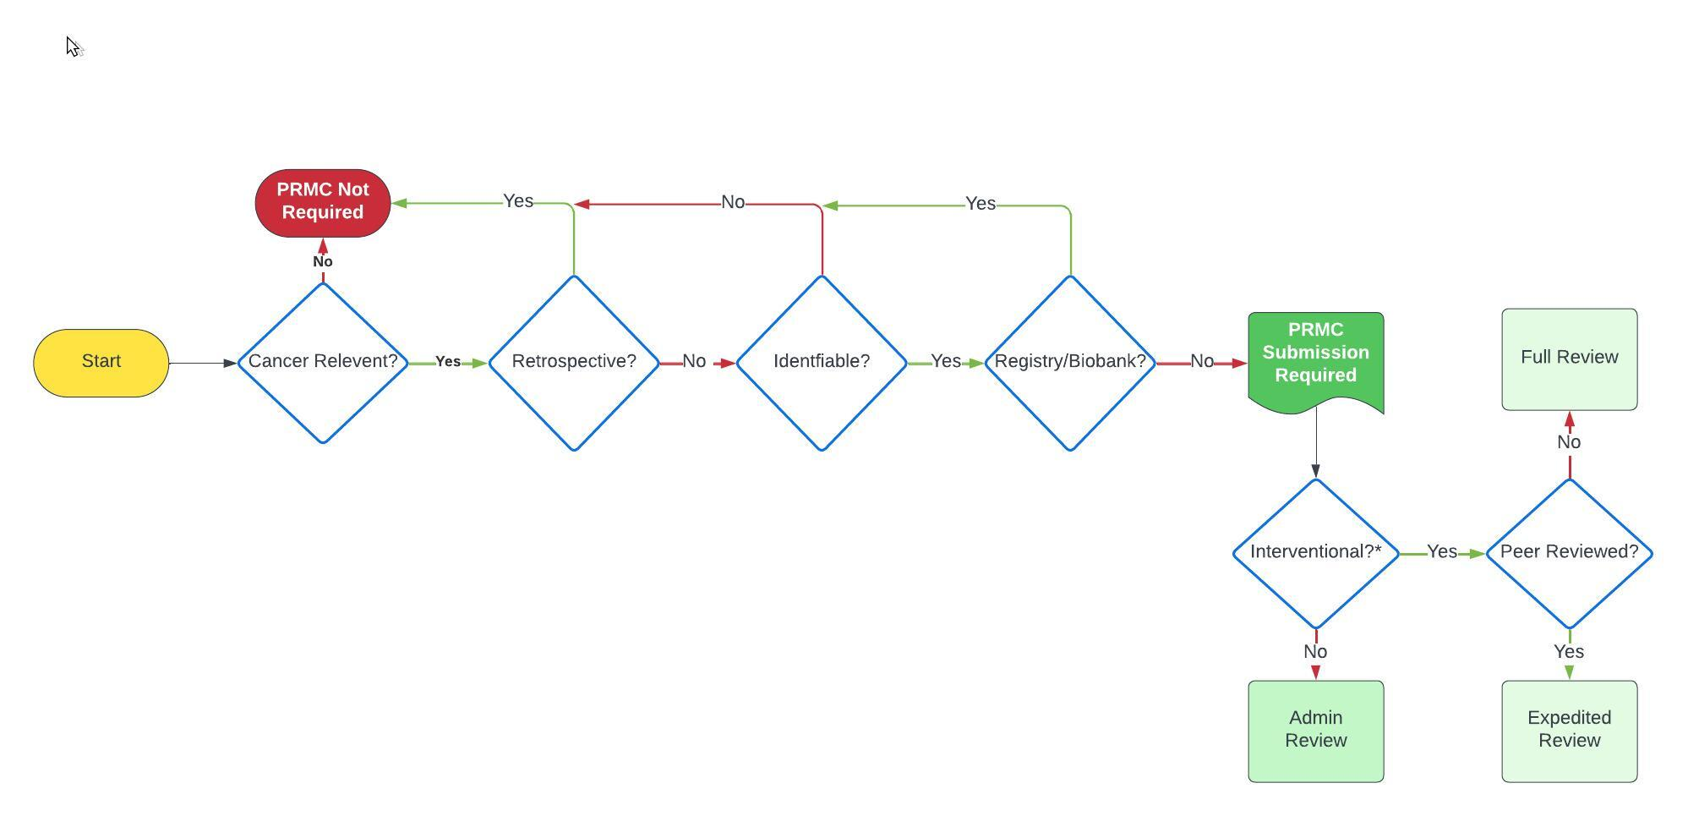

Definitions:
Cancer Relevant: Research with a primary or secondary aim(s) that meets any one of the following criteria:
- Research to understand the causes, trends, nature and mechanisms of cancer and its development including identifying the biological mechanisms, environmental causes, or other factors associated with cancer risk
- Research aimed at cancer detection and screening
- Research aimed at the diagnosis, treatment, or prevention of cancer
- Research aimed at the diagnosis, treatment, or prevention of symptoms or side effects associated with cancer and/or cancer treatment including interventions to improve quality of life
- Research related to the costs of cancer treatment or care, screening, diagnosis and/or prevention
- Research involving the inclusion of oncology providers or oncology-focused clinical, support, and/or research staff as study participants if the primary aims of the research is related to the care or treatment of cancer patients, oncology clinical research, and/or education or surveys related to oncology clinical practice.
- Research in these populations that does not have a primary aim(s) that is directly related to one of the previously defined research categories will be exempt.
- Any other research receiving Cancer Center funding or other material support (i.e. Pilot Project Grants)
- Any other research which enrolls patients with a cancer diagnosis, those that have previously had cancer and/or received cancer treatment, and/or those at risk of developing cancer as a primary population per the protocol inclusion/exclusion criteria

Retrospective: Study intends to use historically obtained samples and/or data under a waiver of consent. Samples/data must be on the shelf (existing) as of the date of the planned submission.

Identifiable: Study intends to use samples and/or data that is identifiable or can otherwise be linked by the research team back to the individual human participant.
Registry or Biobank: Study to support the collection of samples and/or data to be stored for future research purposes only. The submitted protocol does not contain specific research objectives or hypotheses outside of the collection of the samples and/or data.

Interventional*: To determine if your trial meets the definition of an interventional trial please refer to NIH website: https://grants.nih.gov/policy/clinical-trials/definition.htm

Submission of New Clinical Trials
If your study meets the definition of an interventional clinical trial and requires PRMC review, the following items should be submitted to Amber Burnett via email at aburnett@bsd.uchicago.edu.

- Final protocol document
- Investigator Drug/Device Brochure (if applicable)
- New Clinical Trial Submission Form (signed by PI)
- UCCCC Priority Tree^
- 1st Stage Review Documentation^

In addition to the above, your trial must be registered in the Cancer Center CTMS (eVelos) prior to PRMC review. Please contact Jia Cheng for access to Velos.

^Contact Amanda Spratt (Regulatory Director) to obtain access to 1st Stage Redcap and/or priority tree databases.

New Clinical Trials submissions are accepted on a rolling basis and are assigned to the first available PRMC meeting agenda or for expedited review as appropriate after the PRMC Administrator has confirmed that all requirements listed above are met.

Submission of Non Interventional Research
If your study does not meet the definition of a clinical trial and requires PRMC review, the following items should be submitted to Amber Burnett via email at aburnett@bsd.uchicago.edu.

- Final protocol document
- New Protocol Administrative Review Submission Form

In addition to the above, your study must be registered in the Cancer Center CTMS (eVelos) prior to PRMC review. Please contact Jia Cheng for access to Velos.

New non interventional study submissions are accepted on a rolling basis. A PRMC Acknowledgement Letter will be issued after the PRMC Administrator has confirmed that all requirements listed above are met.

Revisions to Ongoing Clinical Trials
Significant changes to ongoing clinical trials must be submitted to the PRMC for review and approval prior to implementation at our center.

Changes requiring PRMC re-review include the following:
- addition of a new drug(s), device(s), or other intervention
- addition or removal of randomization procedures
- addition of a new study arm(s) or disease cohort(s)
- changes to the primary objectives of the research
- addition of minor subjects
- changes to statistical plan or overall sample size (for PI-sponsored/authored trials)
- addition of invasive research-related procedures (i.e. new research biopsies)
- reactivation of study previously closed by PRMS committee

If your clinical trial amendment requires PRMC review, the following items should be submitted to Amber Burnett via email at aburnett@bsd.uchicago.edu.

The submission email must note that this is amendment to an ongoing trial.

- Revised protocol document (clean and tracked changes)
- New/updated Investigator Drug/Device Brochure (if applicable)
- Clinical Trial Amendment Submission Form (signed by PI)
- Updated UCCCC Priority Tree^ (if applicable)

Amendment submissions are accepted on a rolling basis and are assigned to the first available PRMC meeting agenda as appropriate after the PRMC Administrator has confirmed that all requirements listed above are met.

PRMC Continuing Review (Accrual Monitoring)
All ongoing clinical trials are monitored for accrual progress by the PRMC to ensure that accrual is proceeding as projected and that the study can be completed in a timely manner. Trials are expected to enrolled at least 20% of their target enrollment annually to allow for completion within a 5 year period. Trials for rare diseases, including certain biomarker selected trials, may be given additional time to complete.

If the PRMC has concerns regarding trial progress or enrollment, the Principal Investigator will be queried and must provide a written response and corrective action plan with details of why the trial should remain active and plans to improve enrollment. Responses are reviewed by the PRMC for adequacy of response.

Trials which consistently are not meeting enrollment benchmarks or in cases where the Principal Investigator does not reply to PRMC concerns will be administratively closed by the Cancer Center and all enrollment must ceases.

The PRMC retains the final authority to close the trial.

Additional Details
Additional details of the PRMC and its functions can be found on the Cancer Center’s internal website: https://voices.uchicago.edu/cancer-clinical-research/prmc/.

