**BSD 1.0 General Information page**

**

**

**BSD 1.4.1 Funding Source (Grants)**

(This page is shown when user selects Grants with Funding Proposals in AURA Grants Option in question 1c)

**

**

**

**BSD 1.5 Study Locations view, if question 2 is answered ‘yes’ then the following questions are shown:**

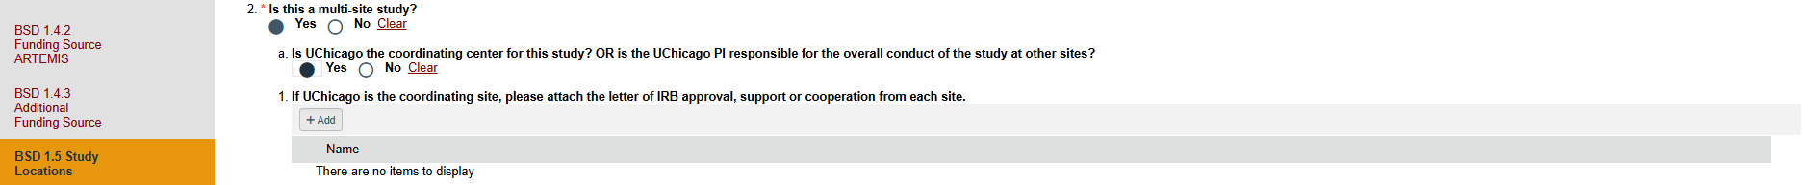

**BSD 1.5 Study Locations view, if question 2 is answered ‘yes’ and question 2a is answered as ‘No’ then the following question is shown:**

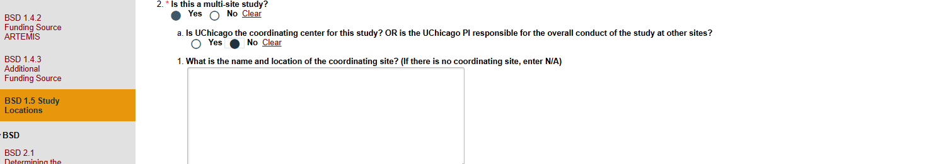

**BSD 1.5 Study Locations view, if question 3 is answered ‘yes’ then the following questions are shown:**

**BSD 1.5 Study Locations view, if question 4 is answered ‘yes’ then the following questions are shown:**

**BSD 1.5 Study Locations view, if question 5 is answered ‘yes’ then the following questions are shown:**

**

**BSD 2.1 Determining the Review Requirements In question 2, when Full Board Review is selected, no further questions are displayed below. The view BSD 2.2, 4.1, 5.1, 5.2, 6.1,7.1, 7.3, 8.1 and Final page are displayed.**

**

**In BSD 2.1, question 2 if Exempt Review is selected then the question 2a is displayed:**

**In BSD 2.1, question 2 if Exempt Review is selected then the following questions 2b and 2c are also displayed:**

**In BSD 2.1, question 2 if ‘Not Human Subject Research Determination’ is selected then the following questions are displayed, and the branching shows only the final page after page 2.1:**

**In BSD 2.1, question 2 if ‘Determination that Project is No Research’ is selected then the following questions are displayed, and the branching shows only the final page after page 2.1:**

**BSD 2.2 Purpose**

In BSD 2.2 Purpose view, question 1 contains the research procedures based on which the subsequent views 3.1, 3.2, 3.3,3.4, 3.5,3.6,3.7 3.8, 3.9, 3.10, 3.11, 3.12 are displayed:

|  |  |
| --- | --- |
| **In BSD 2.2, question 1, when one of the following options is selected:** | **Smartform view displayed in the left navigation upon clicking on save or clicking continue:** |
| Use of Drugs | BSD 3.2 Drugs |
| Use of Medical Devices | BSD 3.5 Devices |
| Use of Biologics | BSD 3.3 Biologics |
| Use of Vitamin/Herbal Supplements | BSD 3.4 Vitamin/Herbal Supplements |
| Novel Surgical, Radiological or Clinical intervention | BSD 3.6 Novel Surgical, Radiological or Clinical intervention |
| Surveys/Questionnaires | BSD 3.7 Surveys/Questionnaires |
| Interviews/Focus Groups | BSD 3.8 Interviews/Focus Groups |
| Deception | BSD 3.10 Deception |
| Observational Research | BSD 3.9 Observational/Ethnographic Research or Participant Observation |
| Specimen Collection and/or Analysis | BSD 3.11 Specimen Collection and/or Analysis |
| Data Collection/Chart Review/Secondary Data Analysis | BSD 3.12 Data Collection |

**In BSD 2.2 Purpose question 6, if the user answered ‘Yes’ then the following questions are displayed:**

**BSD 3.1 Recruitment and Screening**

This view is displayed when question 5 is answered ‘Yes’ in BSD 2.2 Purpose.

If **Advertisements** is selected in question 1 then the following questions are displayed:

If **Identifying UCMC Patients (including medical record screening)** or **Ingalls Patients** option is selection in question 1 then the following questions are displayed:A line of text on a white background

If **Existing Research Registry** option is selected in question 1 then the following question is displayed:

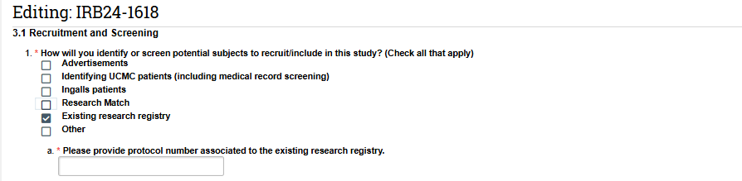

**

**In 3.2, if question 4 is answered ‘Yes’ then the following questions are displayed:**

**In 3.2, if question 5 is answered ‘Yes’ then the following questions are displayed:**

**In 3.2, if question 6 is answered ‘No’ then the following questions are displayed:**

**

**

**

**

**

**

**BSD 3.9 Observational/Ethnographic Research or Participant Observation**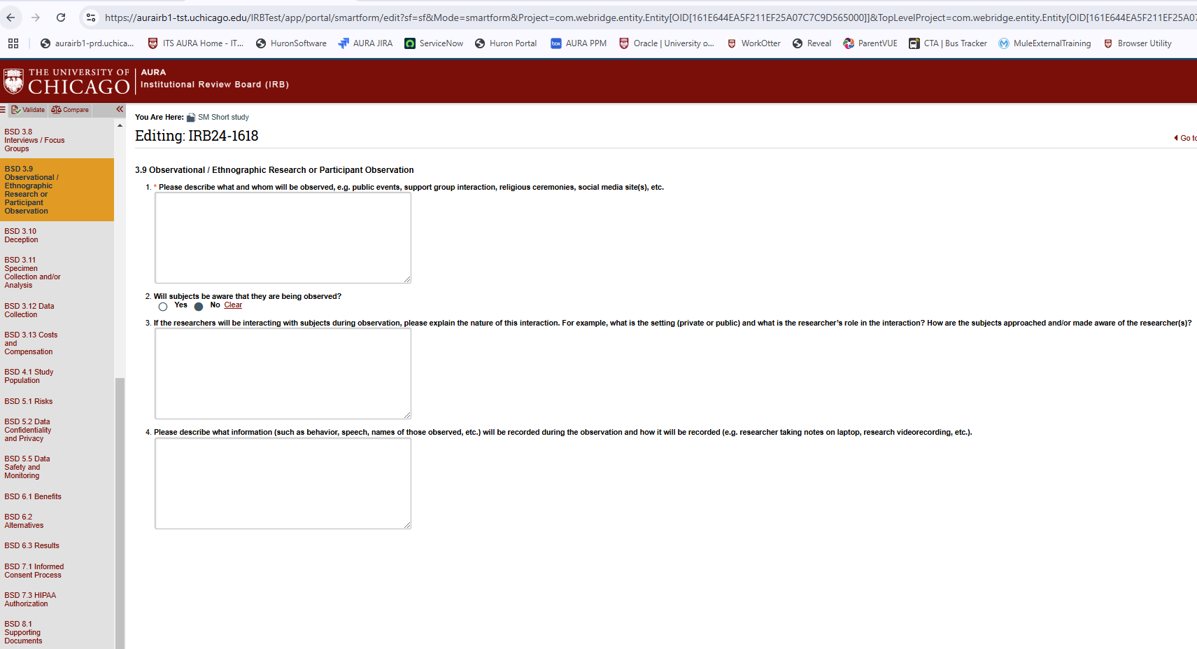

**

**

**

**

**

**

**

**BSD 4.1.3 Wards of State**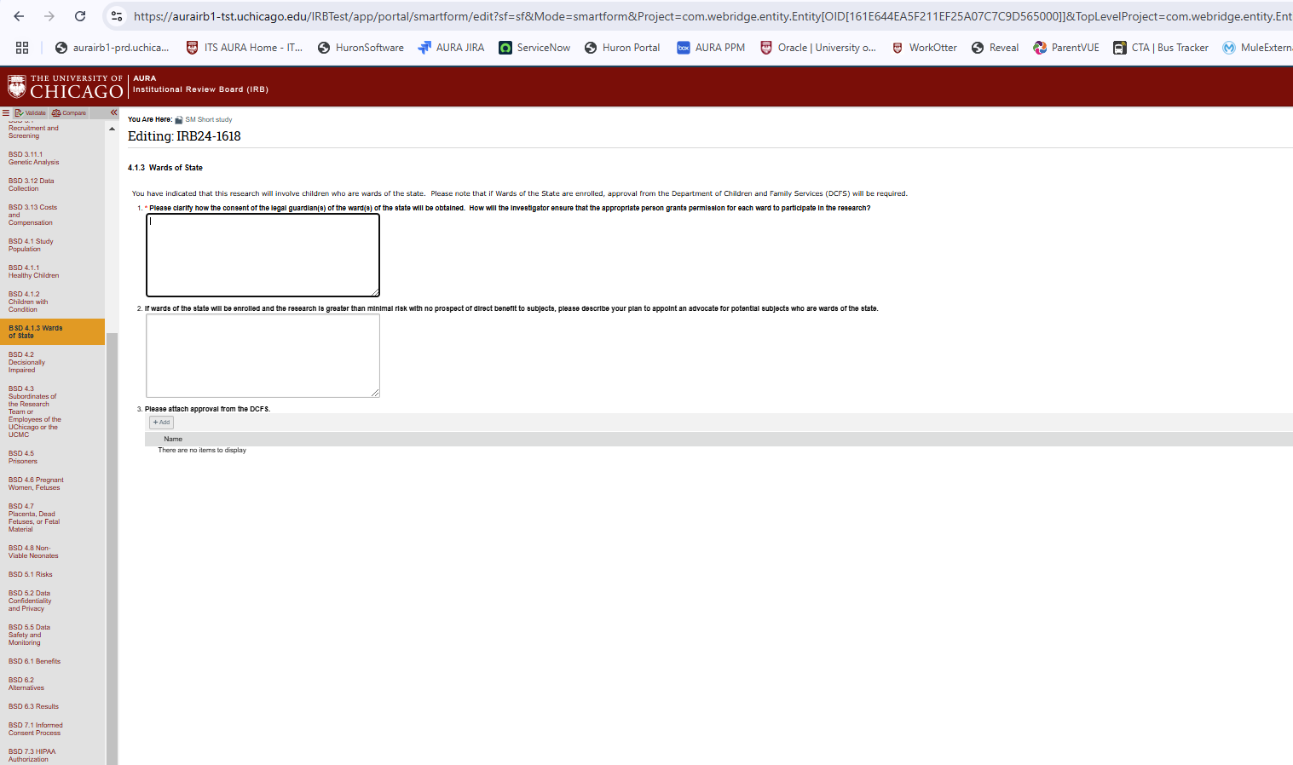

**

**In BSD 4.2, in question 2 when ‘Some may/Some may not’ option is selected:**

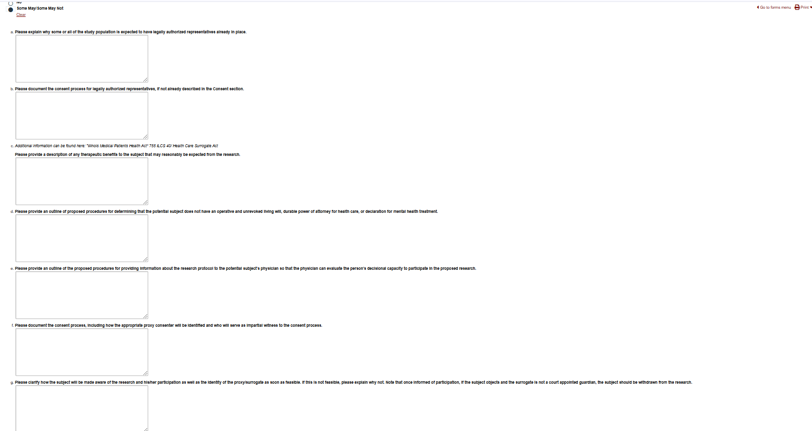

**BSD 4.3 Subordinates of the Research Team or Employees of the UChicago or the UCMC**

This view is only displayed when the option ‘Subordinates of the Research Team or Employees of the Uchicago or the UCMC, including medical students, residents, fellows and staff’ is selection in question 2 of view 4.1 Study population)

**

**

**

**

**

**

**BSD 5.3 Audio/Video Recording and/or Photographs**

**BSD 5.4 Radiation Safety**

**BSD 5.5 Data Safety and Monitoring**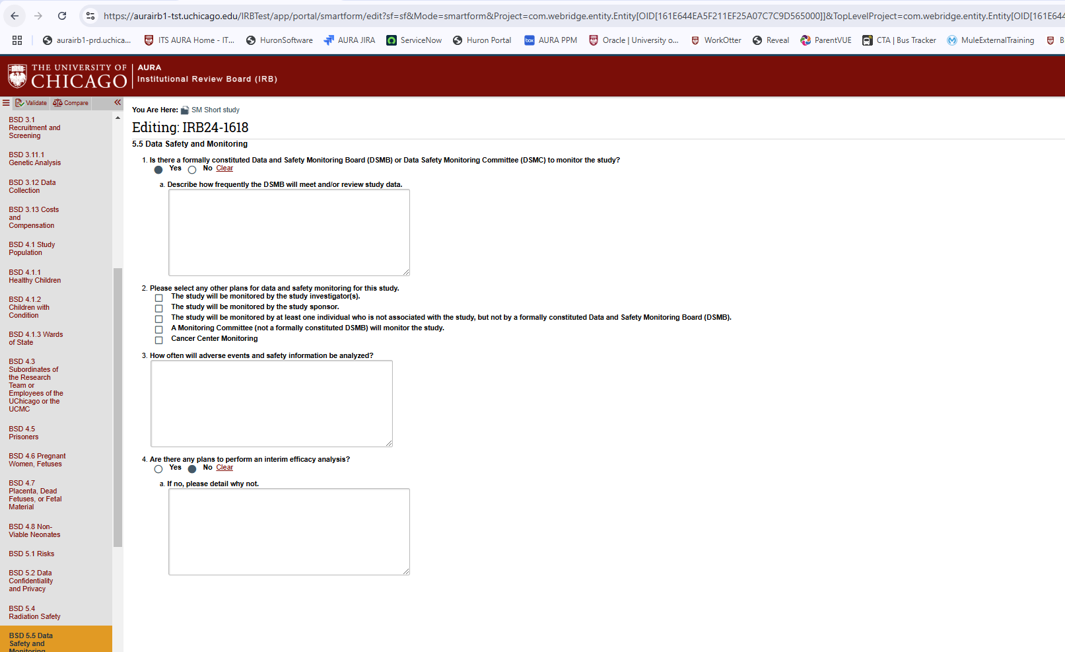

**

**

**

**

If Waiver of Consent Process and Waiver of Consent Documentation is selected in question 1 then 5 sub questions given below are shown:

If the option 2, Waiver **of Consent Process with Consent Documentation Obtained or Altered** is selected then 2 sub questions from informed consent and the 5 sub questions from waiver option are show.

**BSD 7.2 Consent Documentation**

When option 1 ‘Informed Consent’ is selected in question 1 on view 7.1 Informed Consent Process then this view 7.2 is displayed

**BSD 7.2.1 Alteration of Consent**

**

When option 2 **‘Signed HIPAA Authorization (Separate from Consent Form)’** in question 1 in view 7.3 is selected then the following sub question is displayed:

When option 3 ‘**Request for waiver of HIPAA authorization’** is selected in question 1 of view 7.3 then the following sub questions are shown:

**

**

**